|  |
| --- |
| **Synology Backup v1.1** |

1 Configuration 2

1.1 Prerequisites 2

1.2 Preconfigures NAS 3

1.3 New NAS without any configuration 4

1.4 Create a new Volume 21

1.5 Set up scheduled SMART Testing 26

1.6 Create a new shared folder “VEEAM” 29

1.7 Set NTP server 32

1.8 Create a backup group 33

1.9 Create a Backup user 36

1.10 Set up monitoring (SNMP) 39

1.11 Enable SSH 40

1.12 Disable disk hibernation 40

1.13 Enable Monthy Raid Scrub 41

1.14 Disable AFP Service 43

1.15 Enable Notifications 44

1.16 Adjust Notifications 45

1.17 Adjust Notifications 45

# Configuration

## Prerequisites

Connect the backup synology(‘s) in accordance with the port description on the switch(es)

Boot 1 of the synology(‘s)

Connect your pc to the admin-trust network and make sure [Synology Assistant] is installed on the PC

## Preconfigures NAS

Use Synology Assistant to find the Synology (Synology assistant is push able through NS)

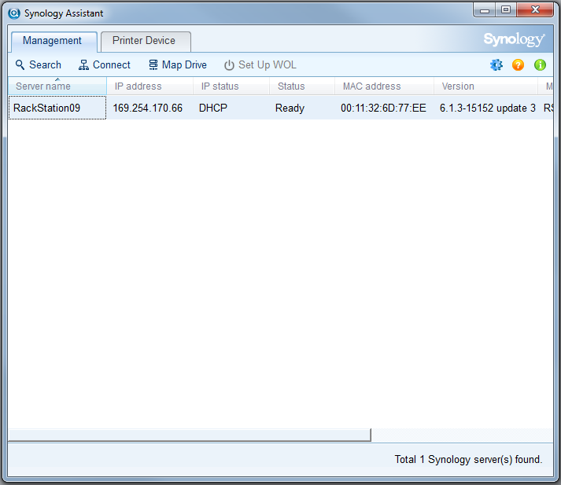

If the status is [Ready] it means the NAS has already been installed

Right click >> Connect

A browser will open with the IP address mentioned in the Synology assistant

> If it’s an old batch, use following >> Username: Admin | Password: Yuiop123

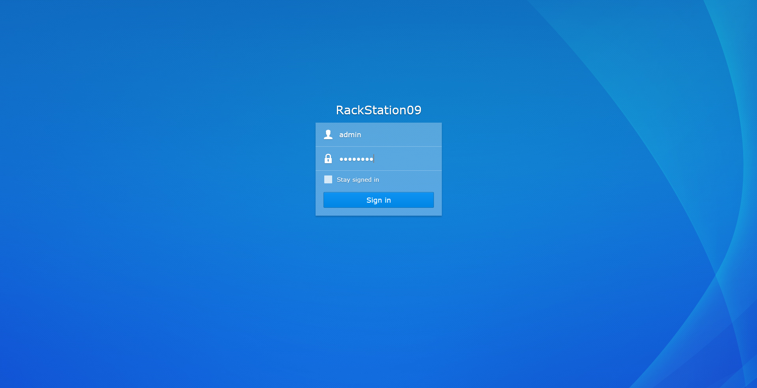

## New NAS without any configuration

Use Synology Assistant to find the Synology (Synology assistant is push able through NS)

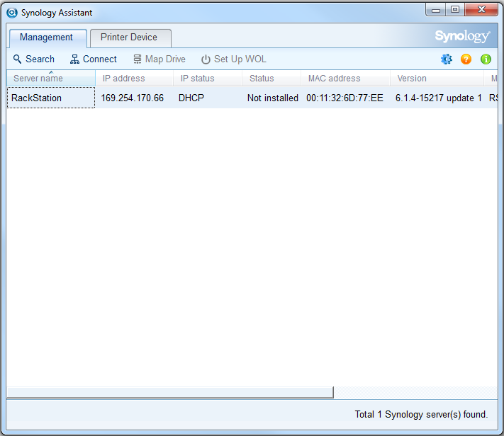

If the status is [Not installed] it means the NAS has already been installed

Right click >> Connect

A browser will open with the IP address mentioned in the Synology assistant

> If its’s a new Synology you will see a wizard to configure the Synology

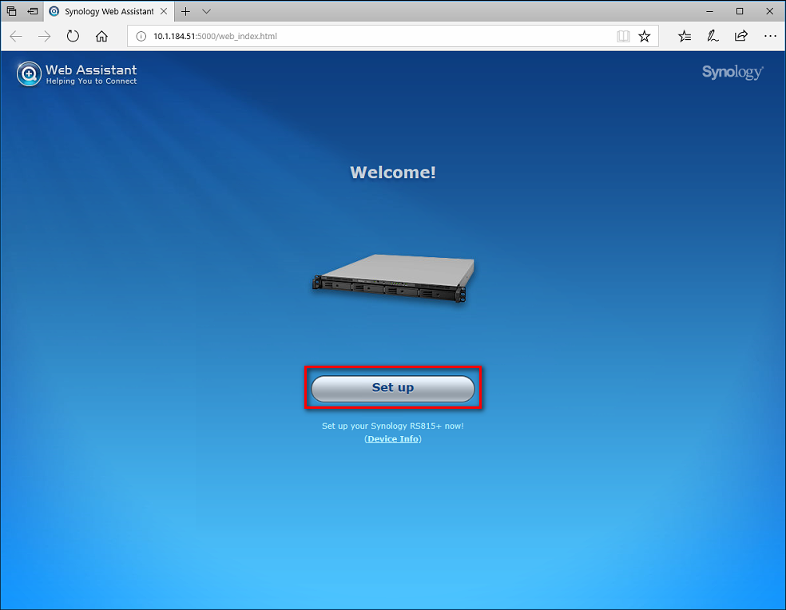

If the synology has access to the Internet, Click [Install Now] | If there is no internet access do it manually

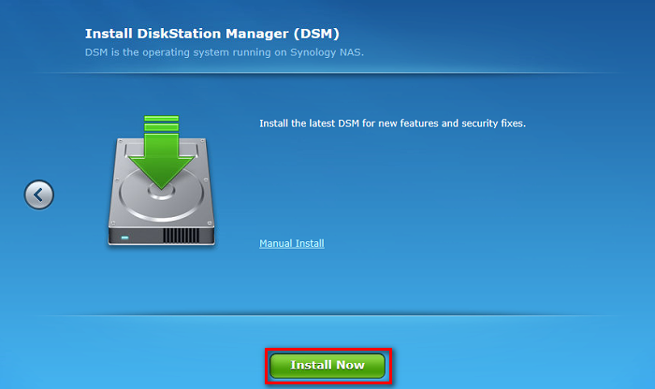

Fill in as below and deselect the checkbox below [Use administrator Password]

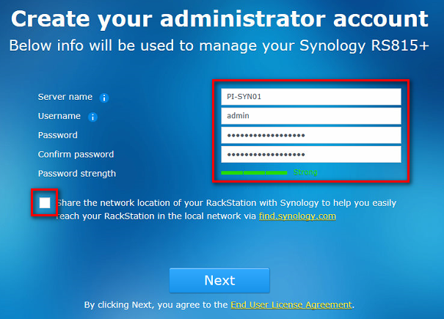

Fill in as shown in the example

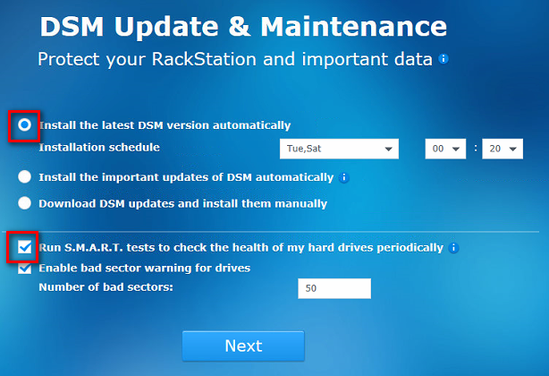

Click [Skip this step]

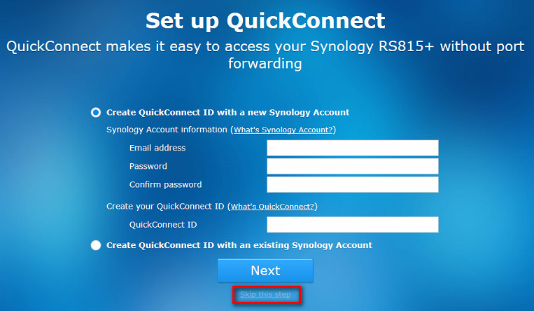

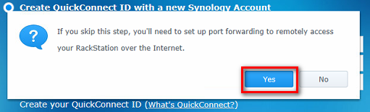

Deselect the checkbox >> Go

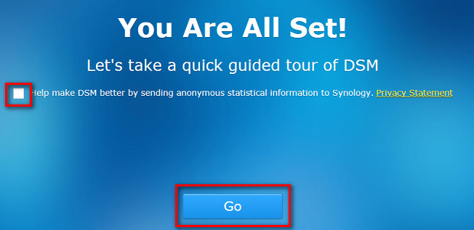

Control Panel >> Update & Restore >> If there is a newer version >> Click Download >> Click Install

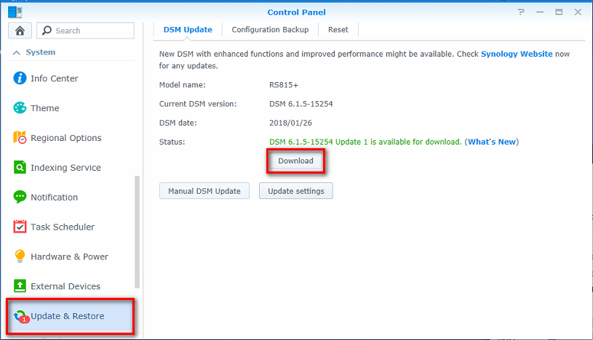

Recheck if the latest version is installed >> Update Settings >> Configure as shown below.

Choose Download DSM updates but let me choose whether to install them in the dropdown box.

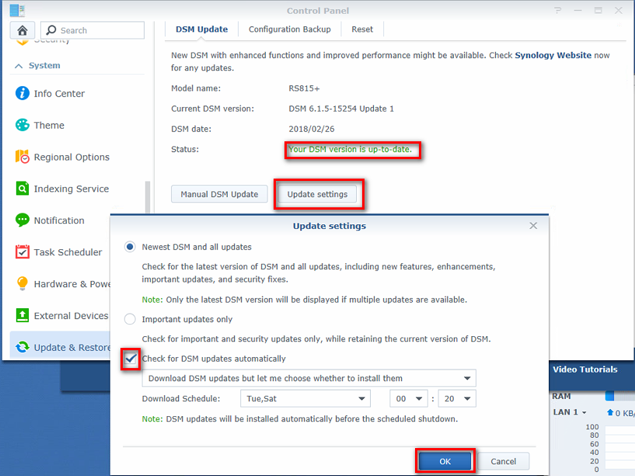

Control Panel >> Network

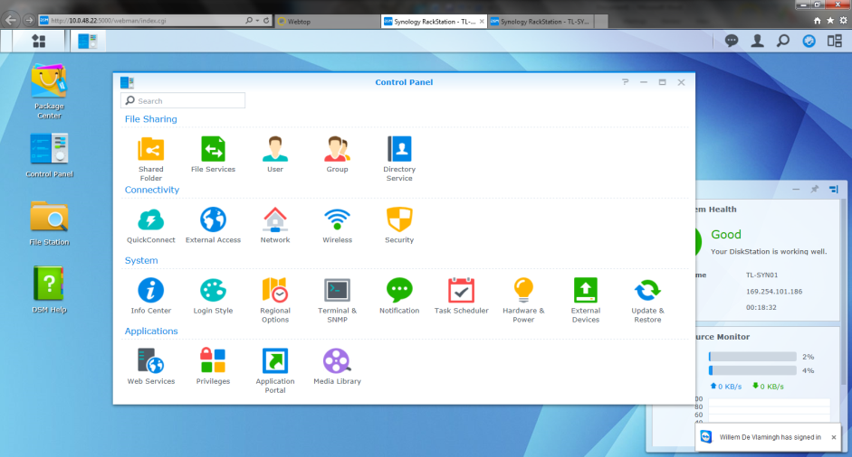

Go to the 2nd tab interfaces and select the interface you would like to edit

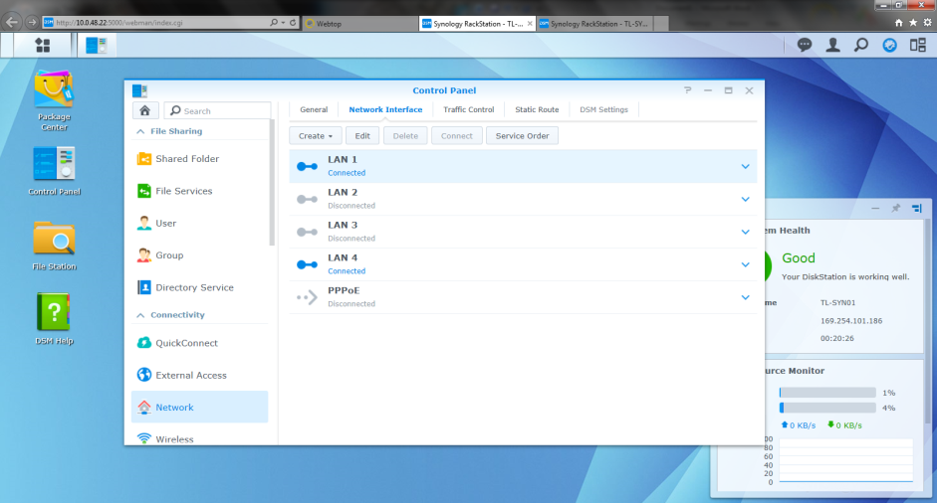

Press the edit button and adjust the interface IP settings for LAN1

IPv4 can stay on DHCP since this interface will link the 2 NAS and will be used as heartbeat.

Disable IPv6 and deselect [Set as default gateway] in the IPv6 tab

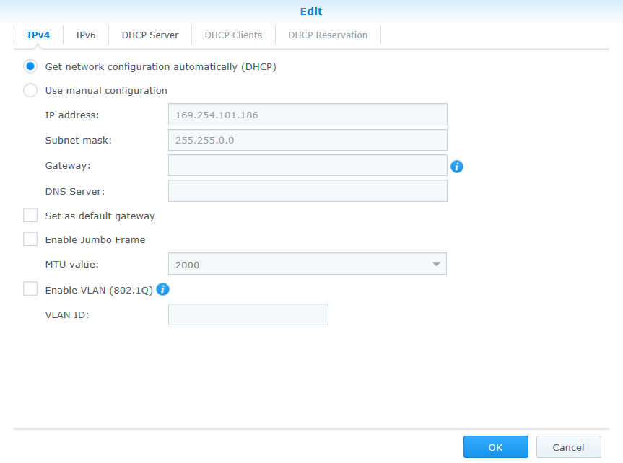

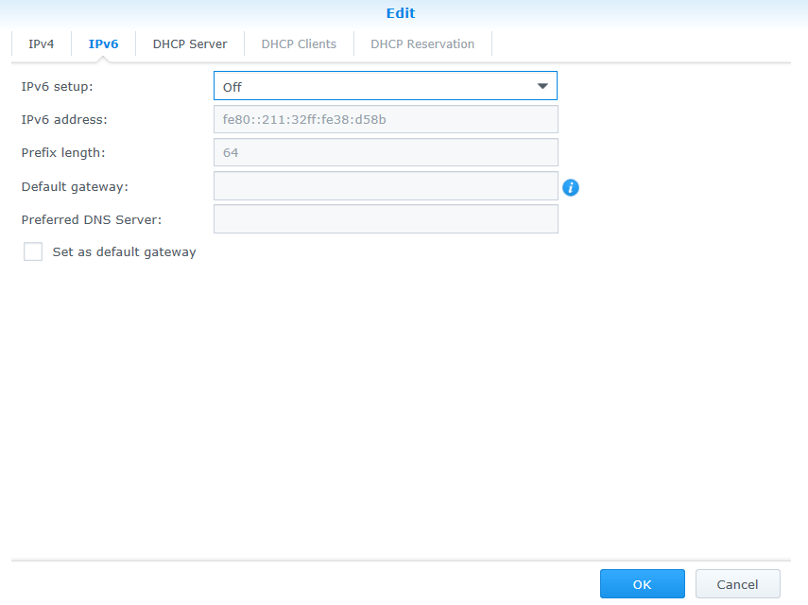

Press OK and edit LAN4, which will be used for MGMT (ADMIN-TRUST) and disable IPv6

* Set IP@ as below >> X.X.X.22 [SYN01] | X.X.X.23 [SYN02]
* Enable [Set as default gateway]

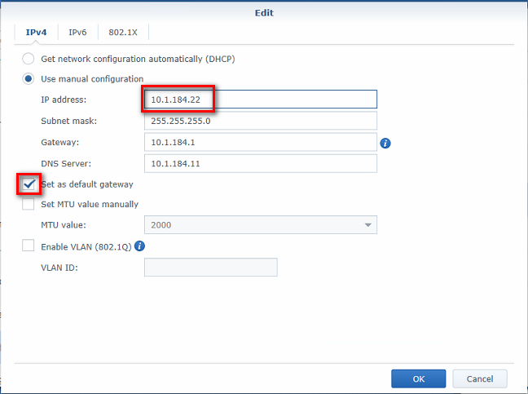

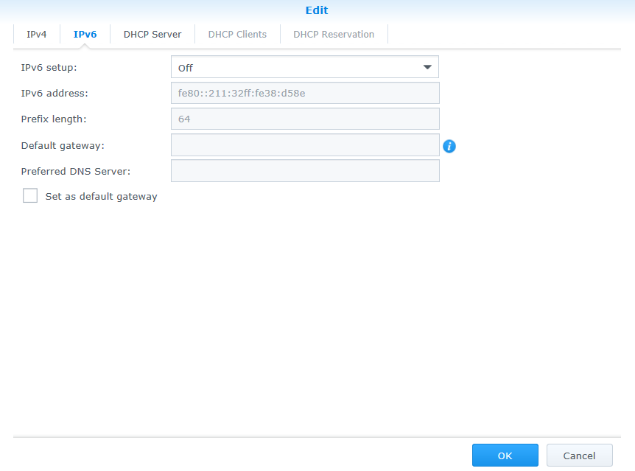

Select LAN2 and click “Create” > “Create Bond”

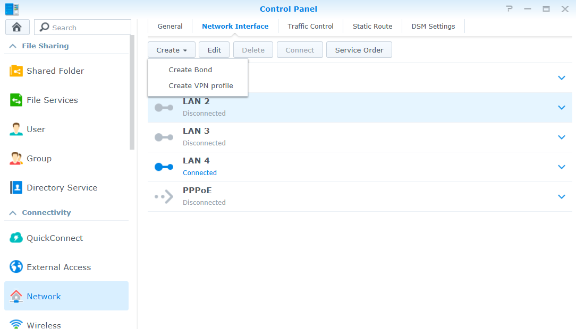

Select IEEE802.3 ad

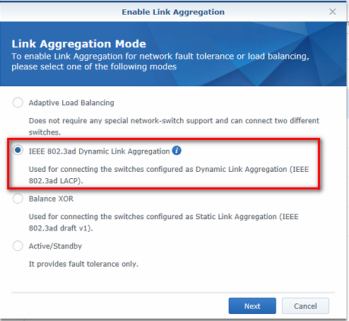

Select LAN2 and LAN3

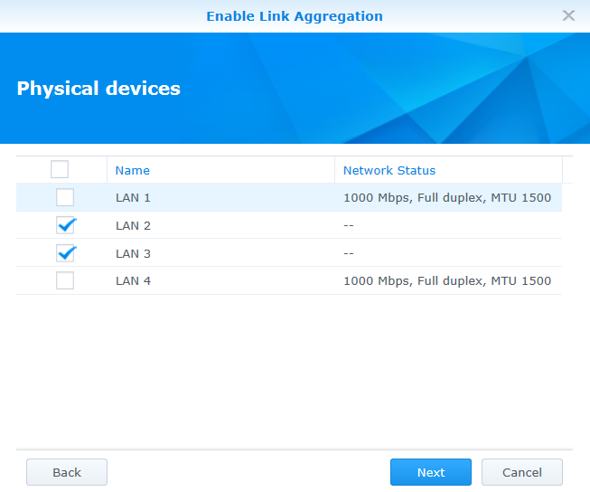

Fill in as the example below on both hosts SYN01 and SYN02

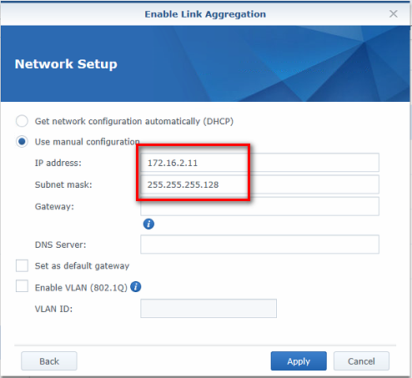

After configuring the Bond interface the network tab should look like this.

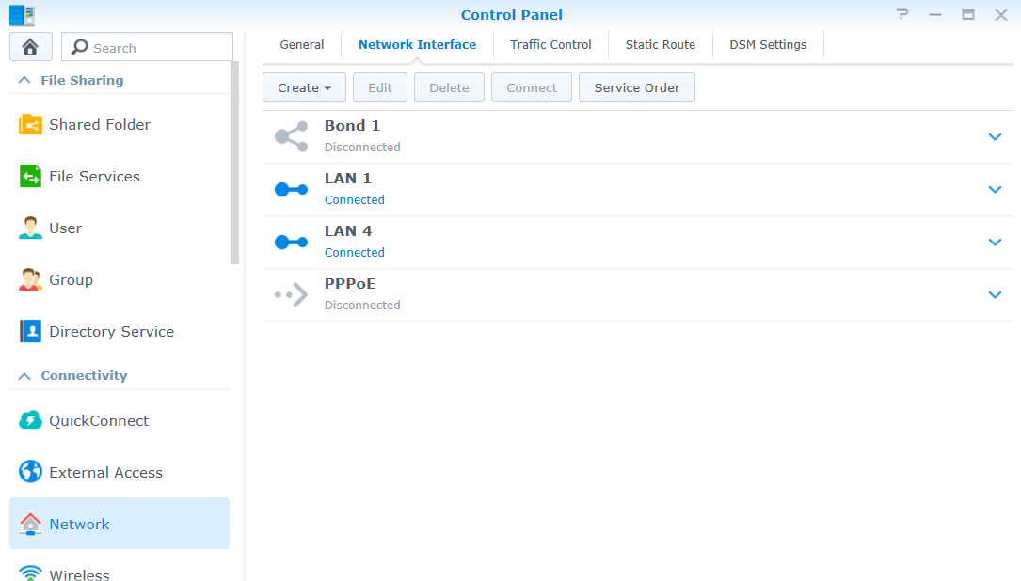

Disable IPv6 on “Bond 1”

Disable “Set as default gateway”

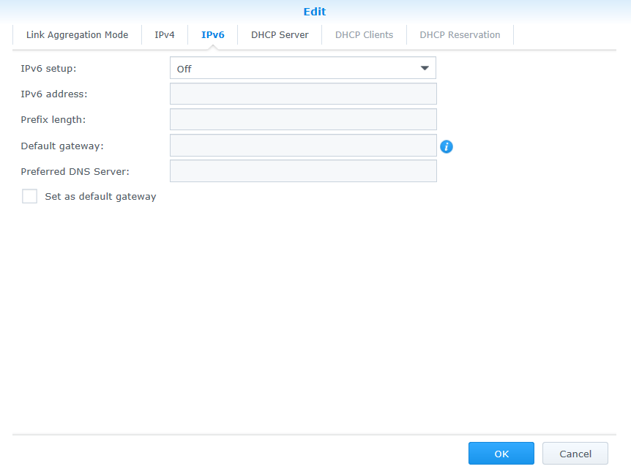

Enable Wake on LAN for LAN4

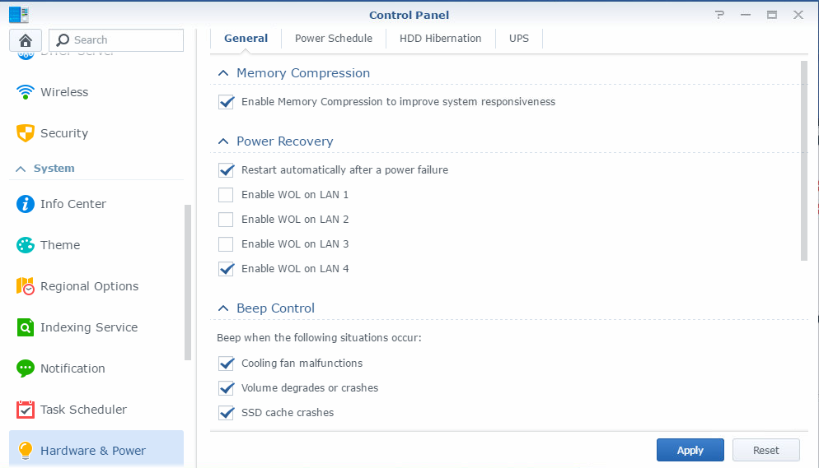

**Repeat the previous steps onto the 2nd NAS**

## Package install

Install on both Synology’s

High availability package

Location: \\Jdn-file01\ict_new_standard_sites_vessels\Software\Current\Synology

Filename: HighAvailability-avoton-X.X.X-XXXX.spk

Open [Package Center] and go to [Manual Install]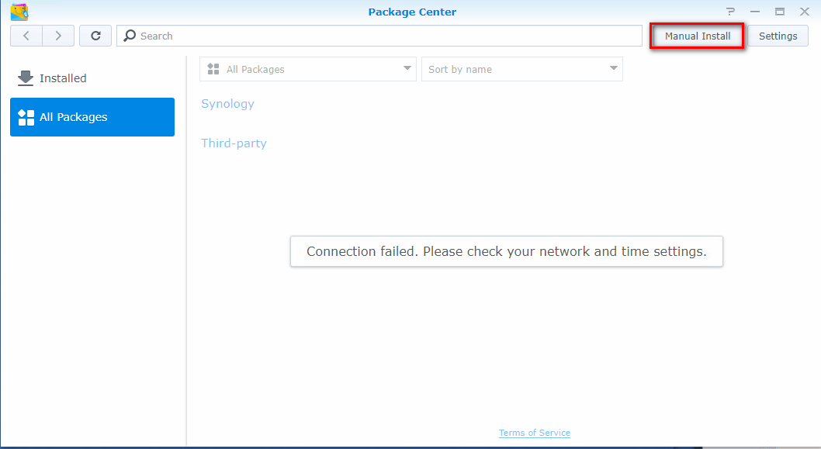

Browse to the pkg file and Click [Next] to import the package

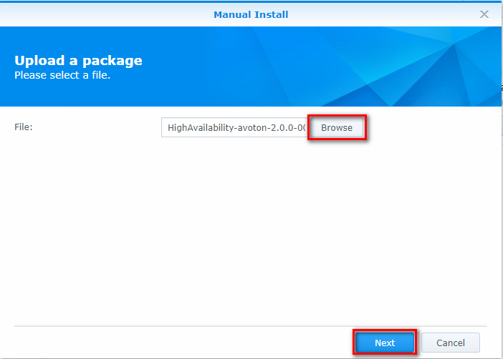

Click [Apply] to install the package on the device

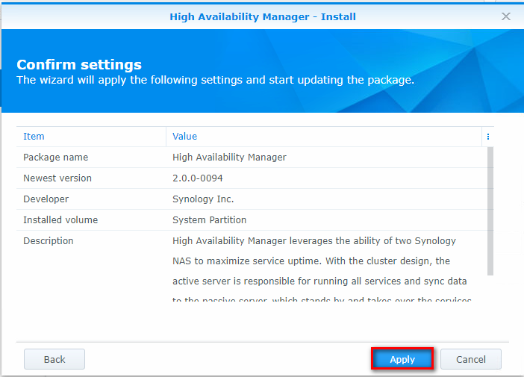

Ignore the following error and check the installed packages



If the replication service & snapshot replication packages are missing, you can ignore this because these will be installed later.

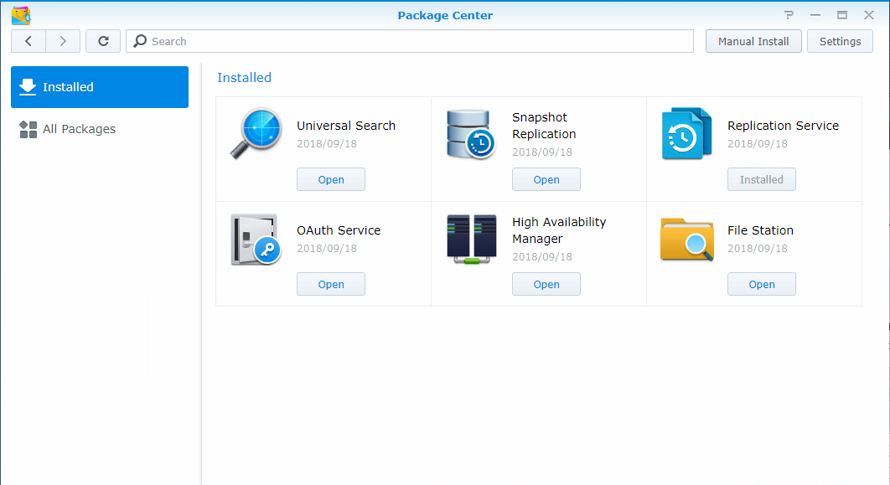

## High availability cluster

Return to the “Main menu” of the 1st NAS

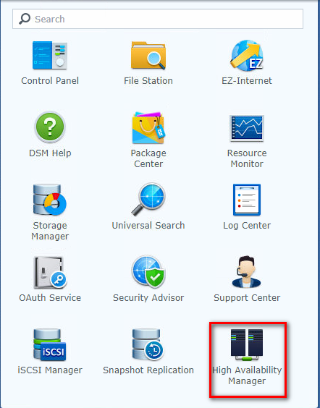

Click the “Create HA Cluster” button

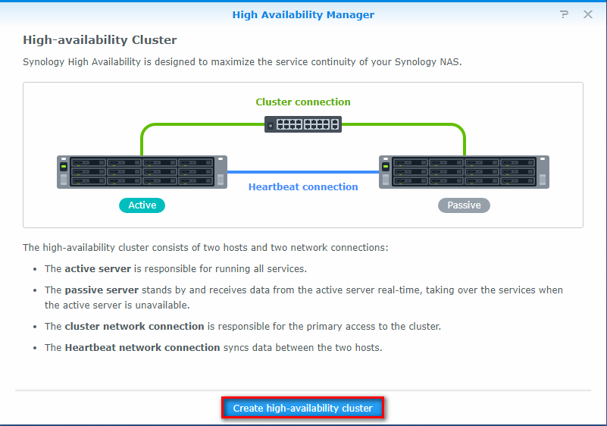

[Next]

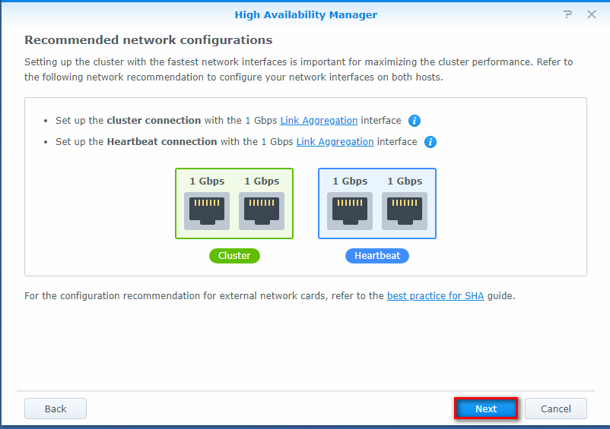

Cluster: [LAN 4] || Heartbeat: [LAN 1]

Click [Next]

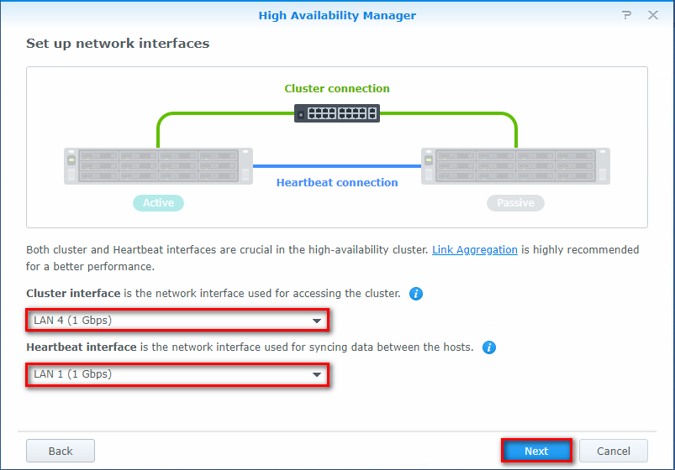

Use admin credentials

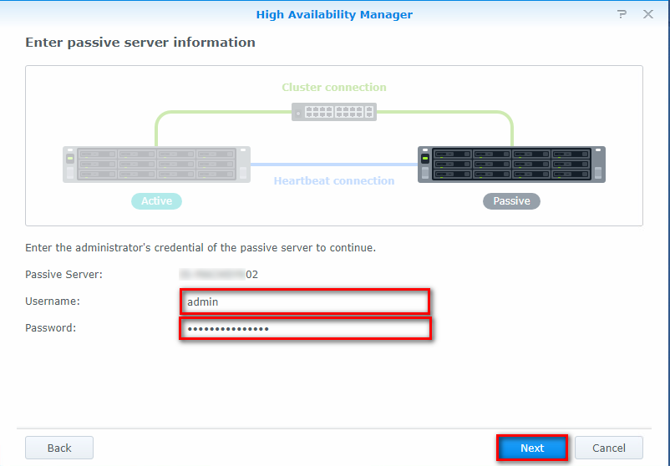

Fill in name and IP address [admin-trust]

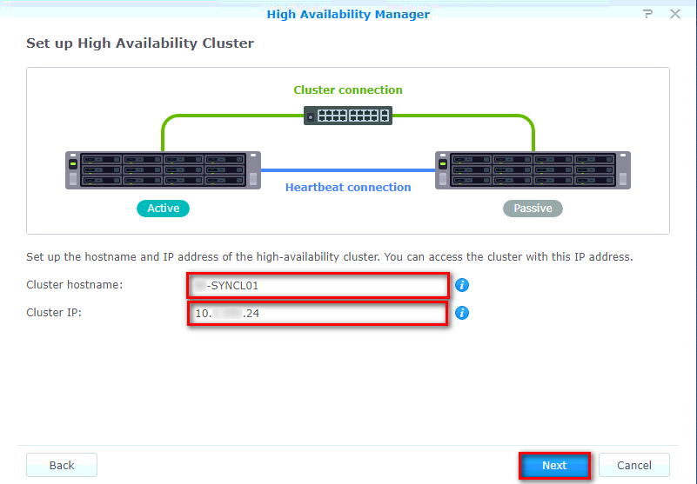

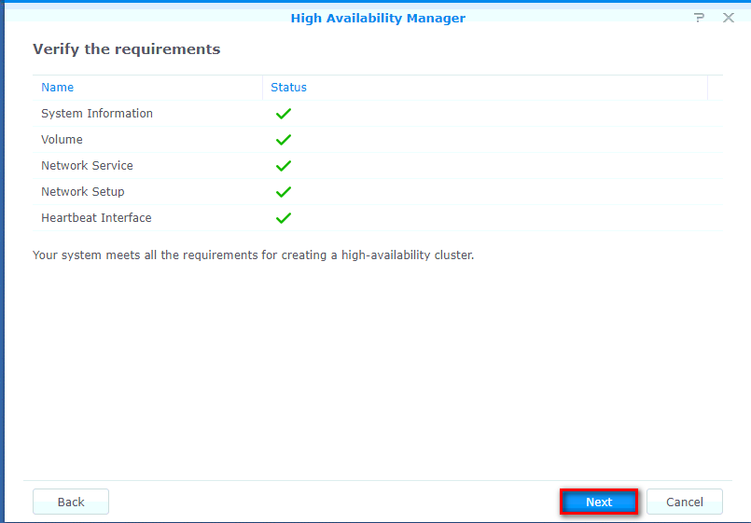

Select [Erase all data for a fast cluster creation]

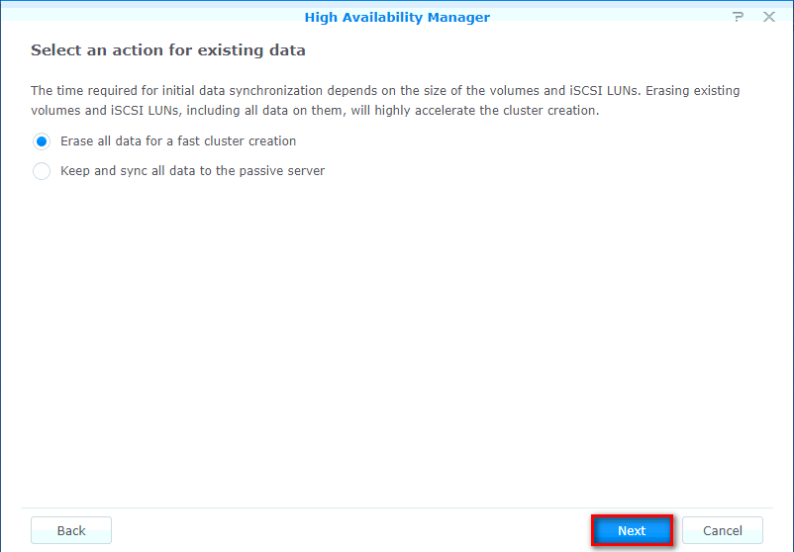

Fill in admin password

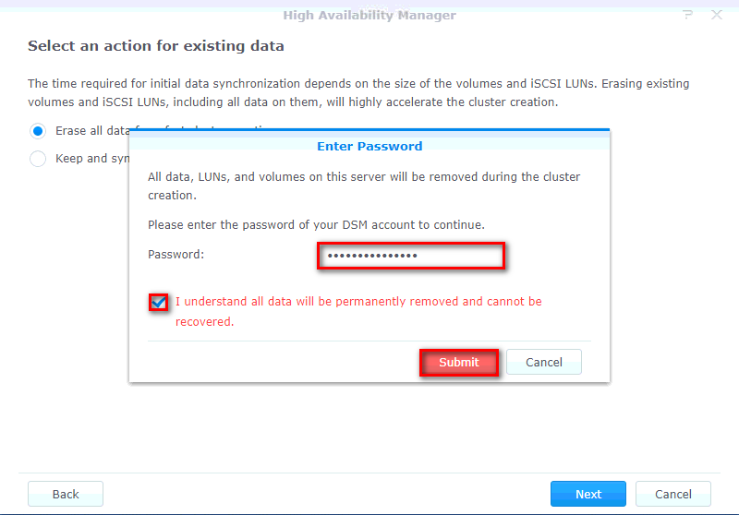

Check the values

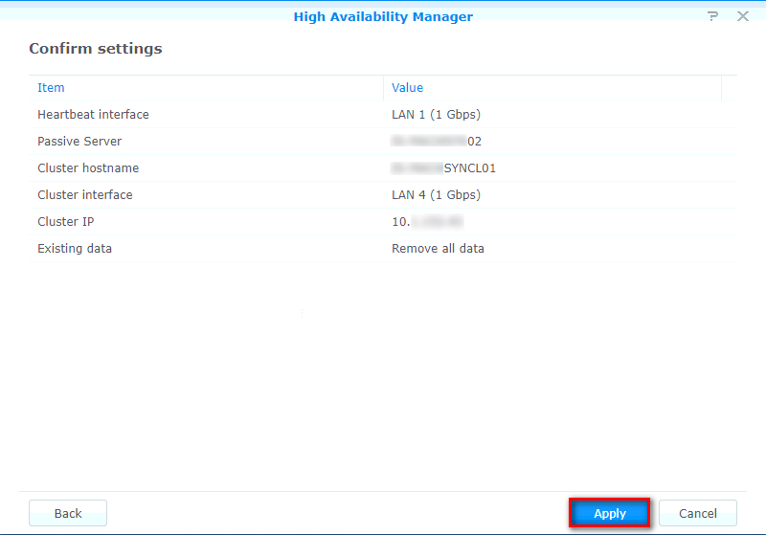

Select [I understand …] >> Yes

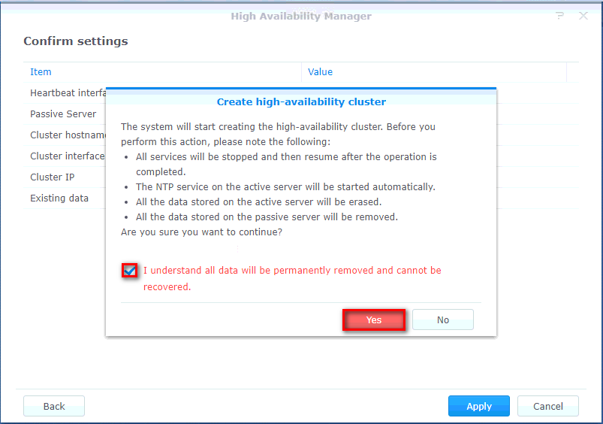

[Manage network interface]

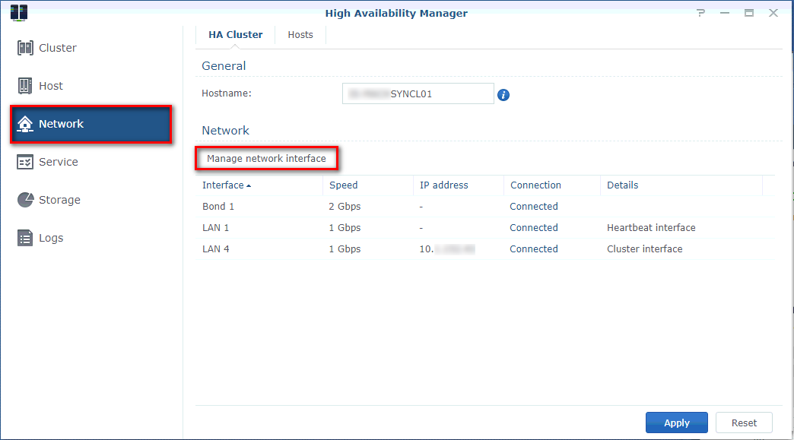

Select [Bond 1] || Fill in Bond’s IP address (172.16.2.10)

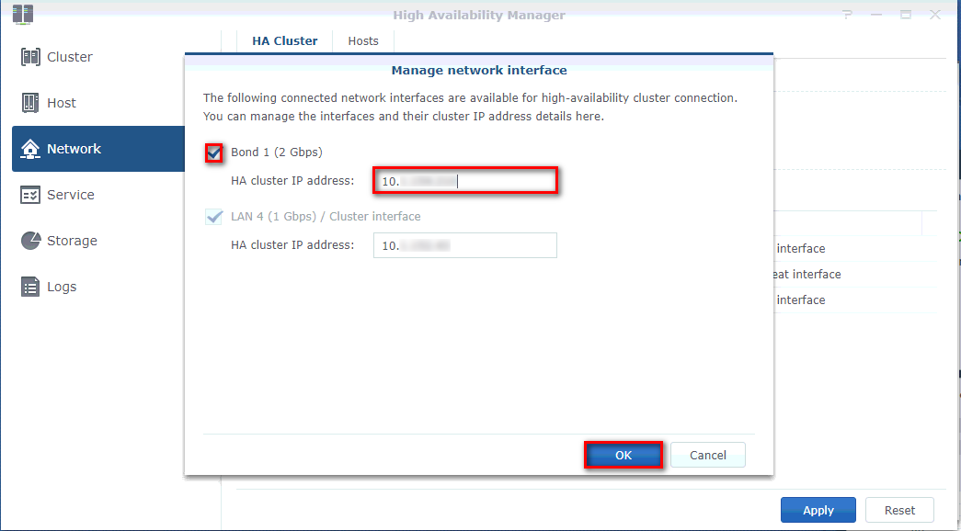

## Create a new Volume

Open the Synology storage manager

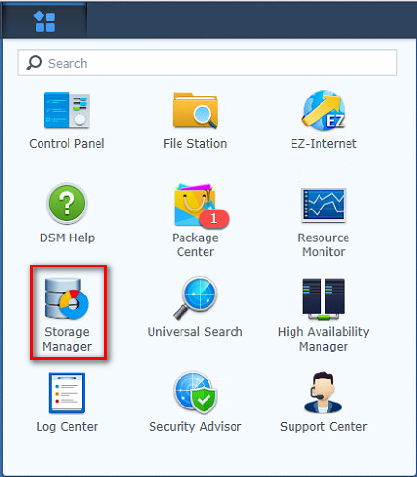

Select volume and click create

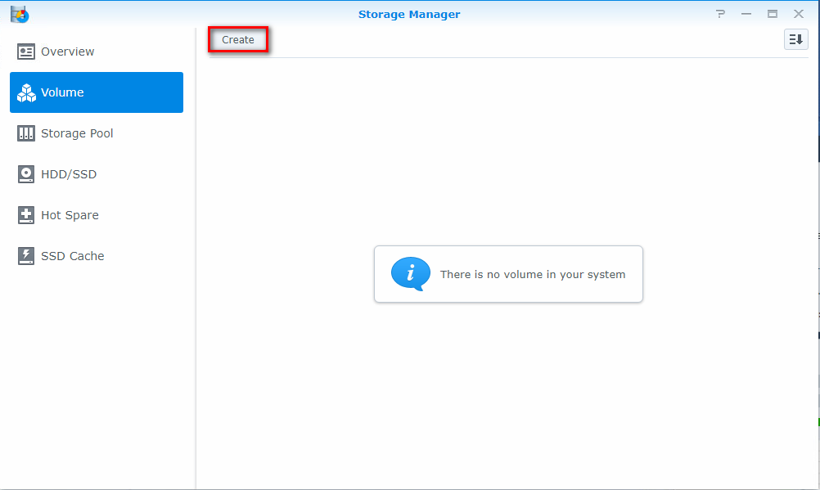

Select custom instead of SHR and press next

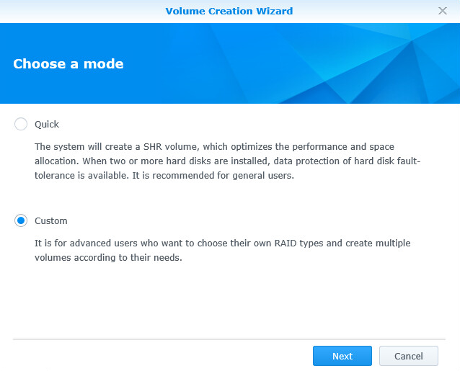

Select [create a new storage pool]

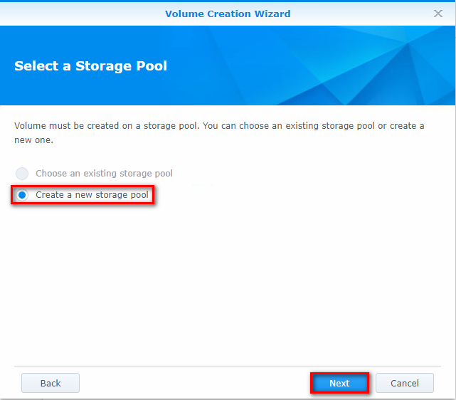

Select [Better performance]

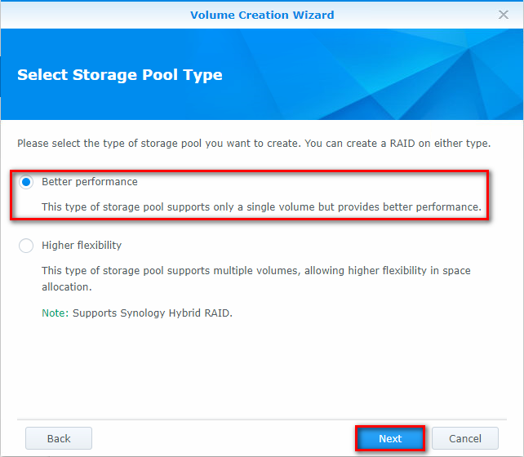

Select [RAID5]

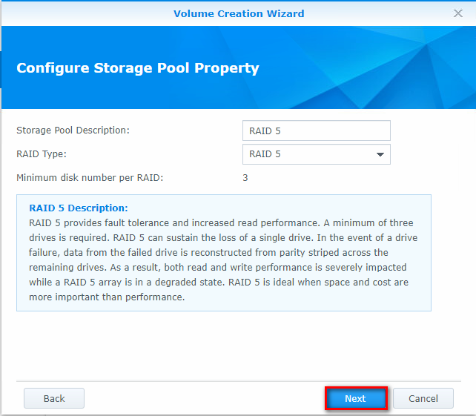

Select [Disk #]

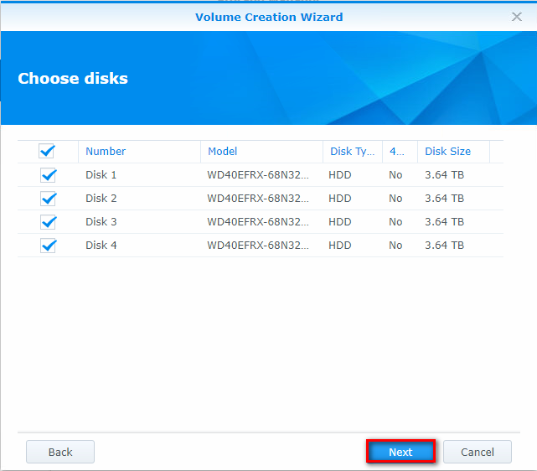

[OK]

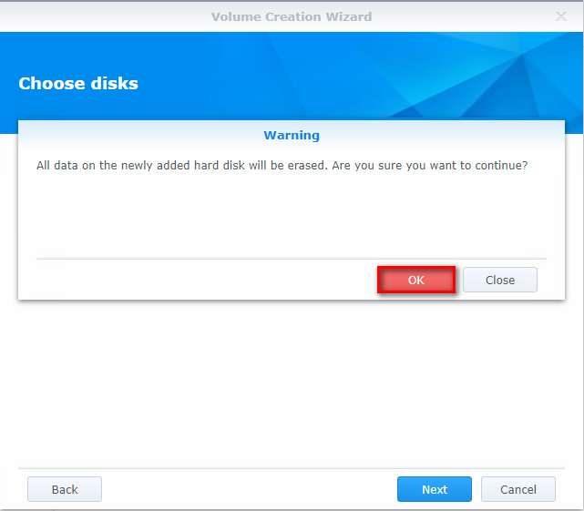

Change Description to [RAID 5, Ext4]

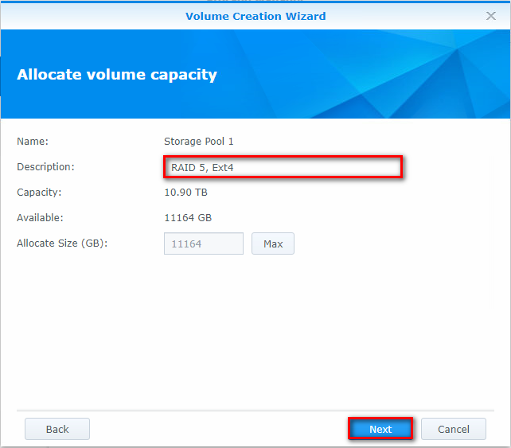

Select [ext4]

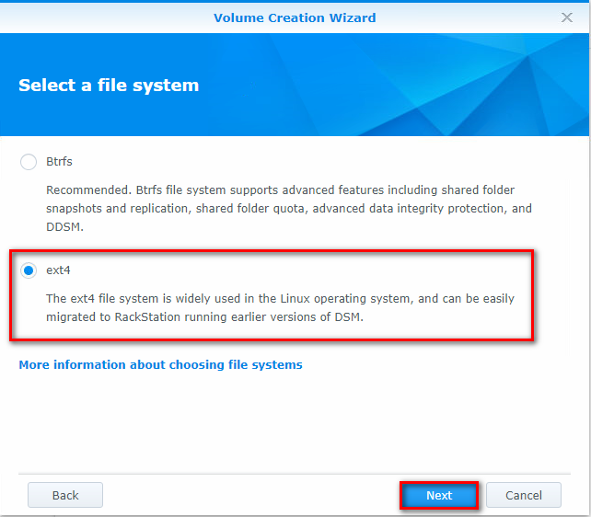

[Apply]

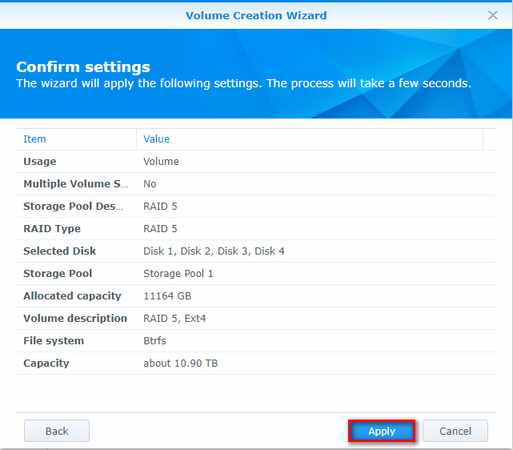

Install following packages in the mentioned order:

Replication Service Package

Location: \\Jdn-file01\ict_new_standard_sites_vessels\Software\Current\Synology

Filename: ReplicationService-x86_64-X.X.X-XXXX.spk

Snapshot replication Package

Location: \\Jdn-file01\ict_new_standard_sites_vessels\Software\Current\Synology

Filename: SnapshotReplication-x86_64-X.X.X-XXXX.spk

## Set up scheduled SMART Testing

In the Storage manager > HDD/SSD > Test Scheduler section, edit both rules.

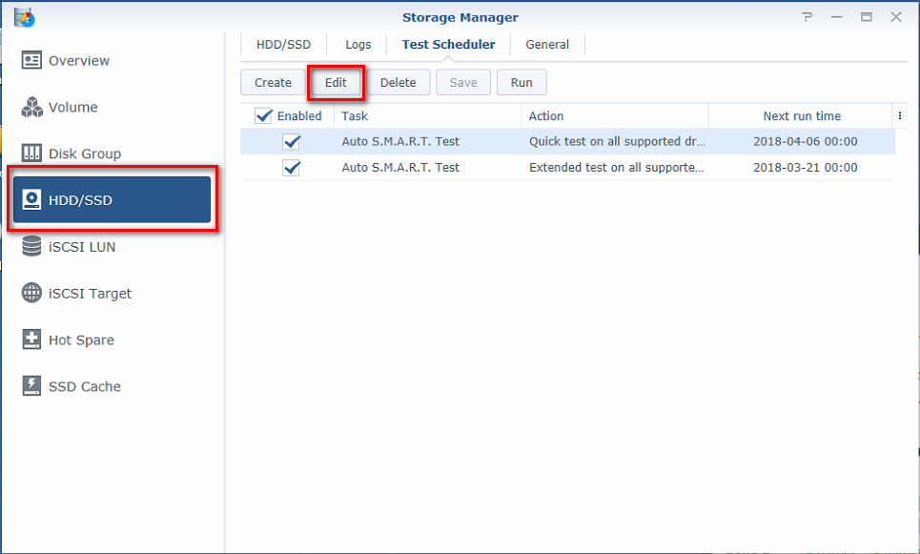

1 quick SMART test that runs weekly and 1 extended SMART test that runs monthly

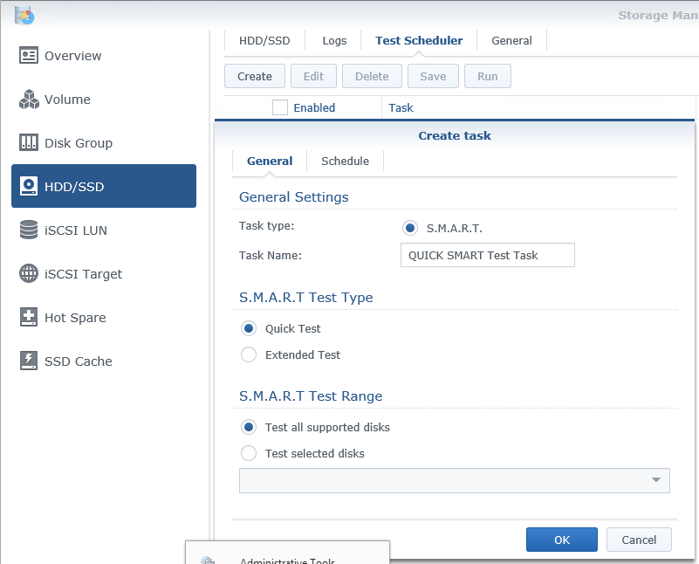

Select a day to run the quick test weekly.

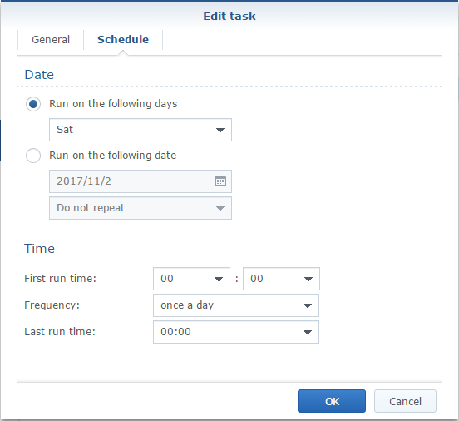

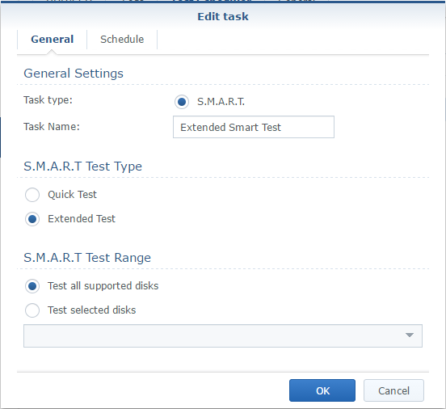

Select a start date and select repeat monthly for extended.

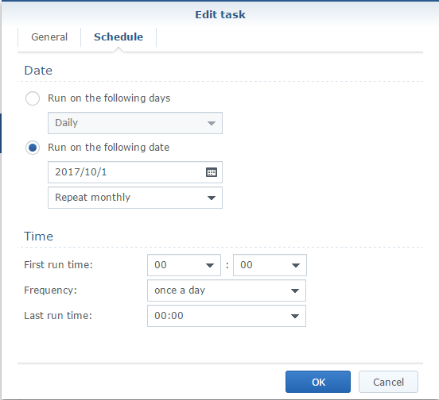

## Create a new shared folder “VEEAM”

Control Panel >> Shared folder >> Create >> Create

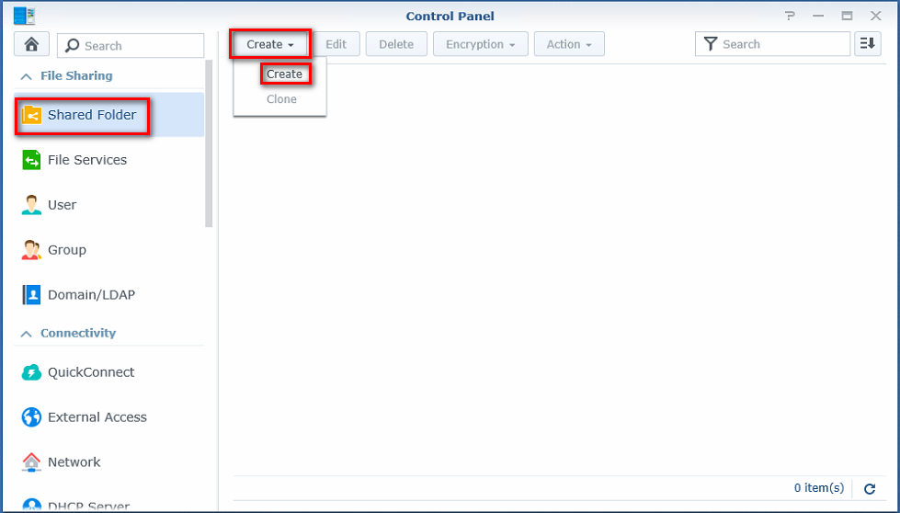

Fill in as shown below

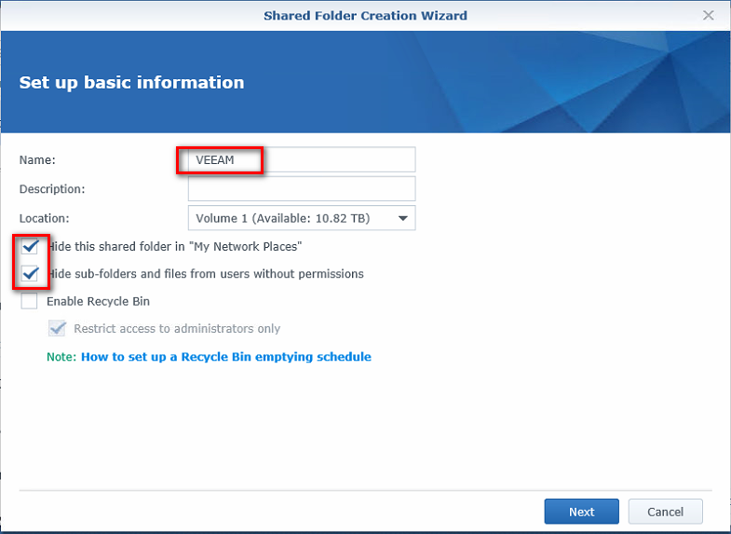

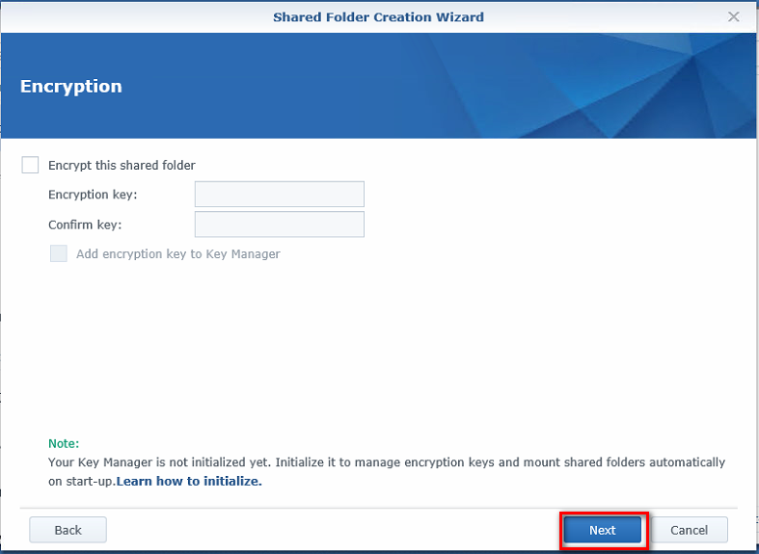

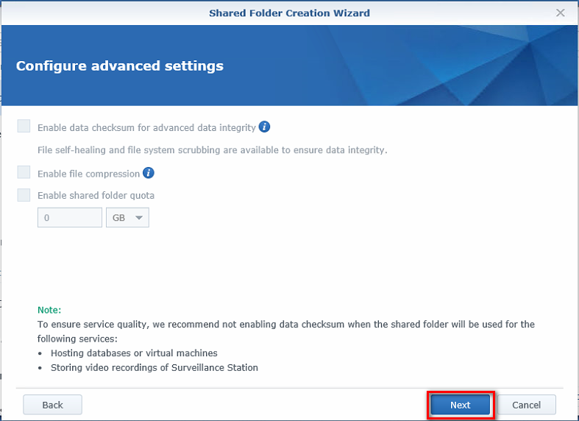

Apply to finish

Place the same settings as below

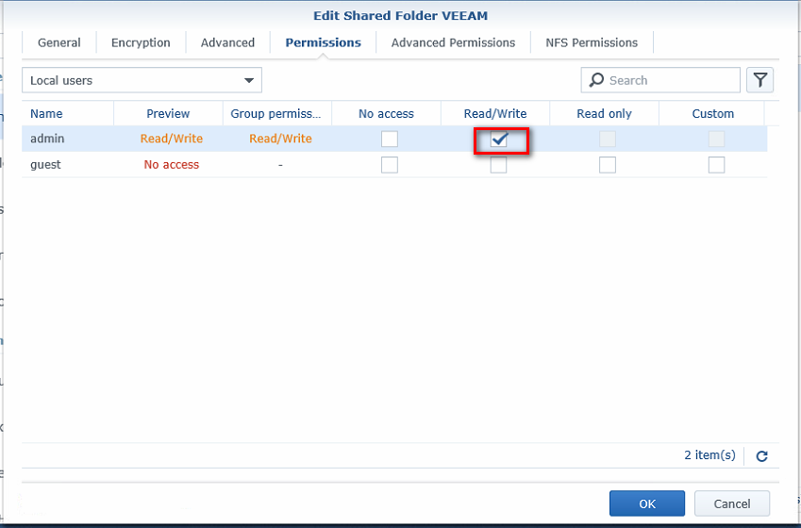

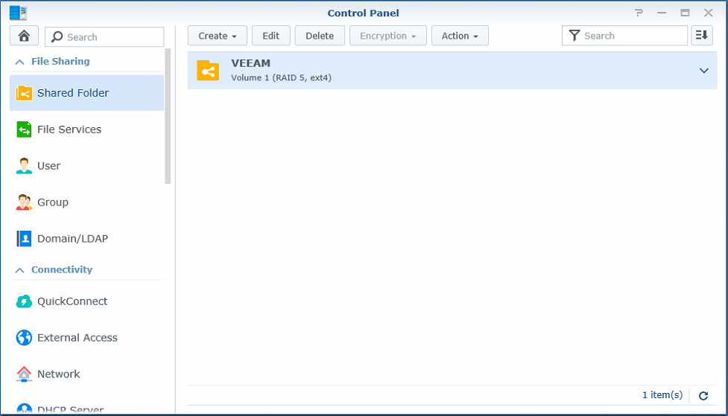

## Set NTP server

Select “regional options” in the “control panel”.

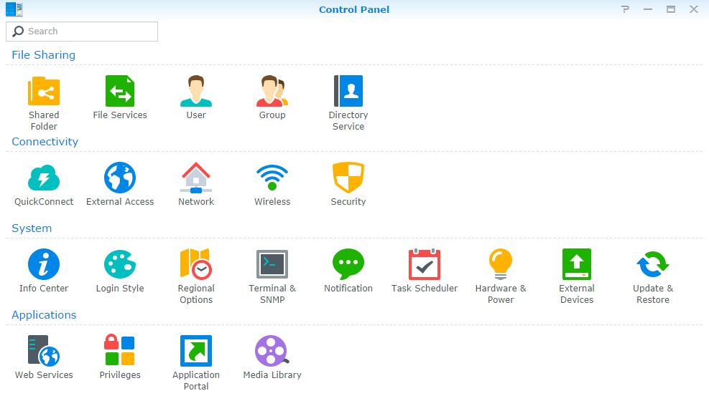

Set the Time zone to UTC and fill in the IP address of the domain controller in the server address bar

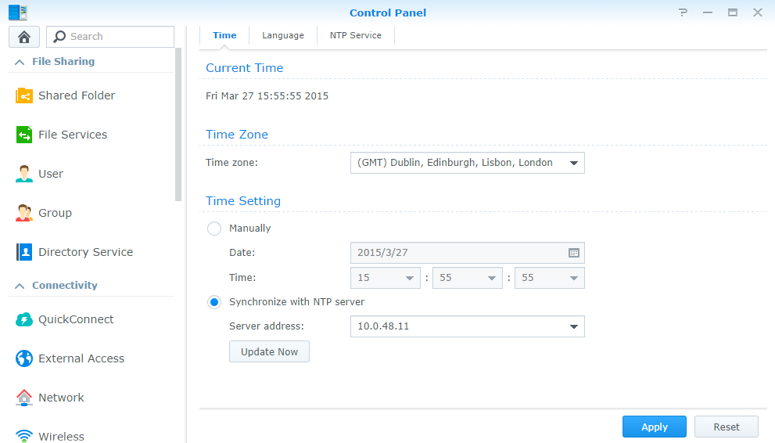

Press update now to make sure the device is synchronized

## Create a backup group

Select group in the control panel and click on the create button

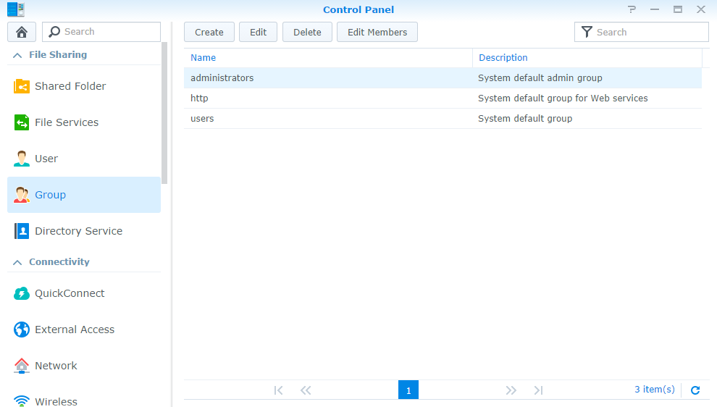

Create a new group named “Backup” and press “Next”

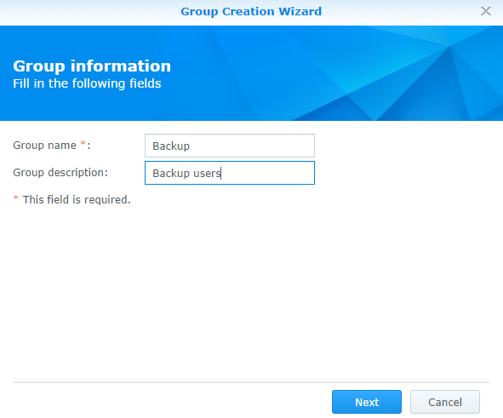

Give the backup group RW rights to the Veeam backup share

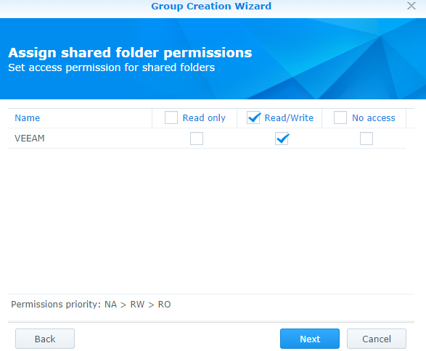

Don’t enable quota settings

Don’t assign application permissions

Don’t set speed settings

Apply the configured settings

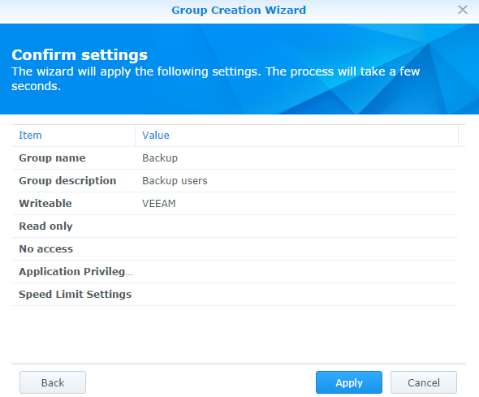

## Create a Backup user

Select “User” in the control panel and click on the create button

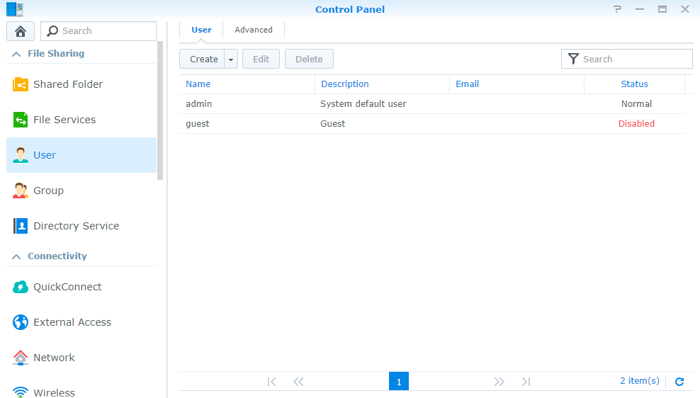

Create a “srv_backup” user, including password and select that the user is not allowed to change his password

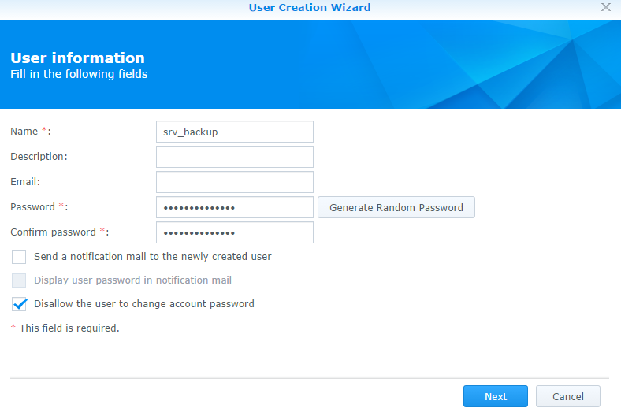

Add the user to the backup group

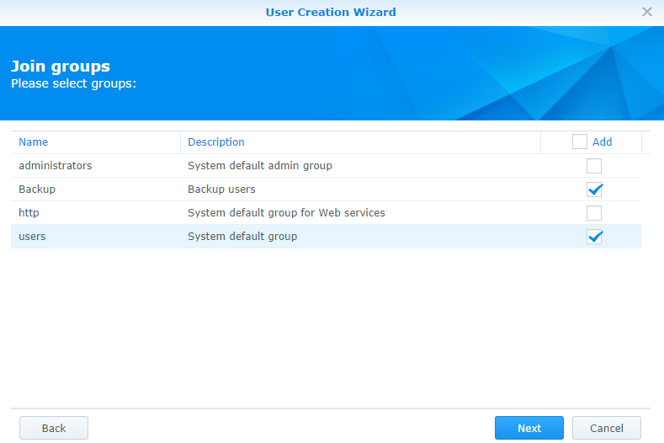

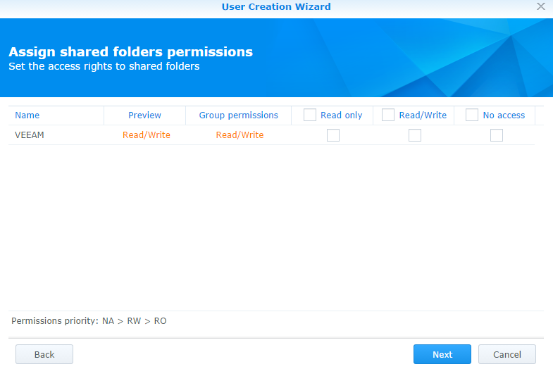

Don’t set usage quota

Don’t assign application perissions

Don’t assign speed limits

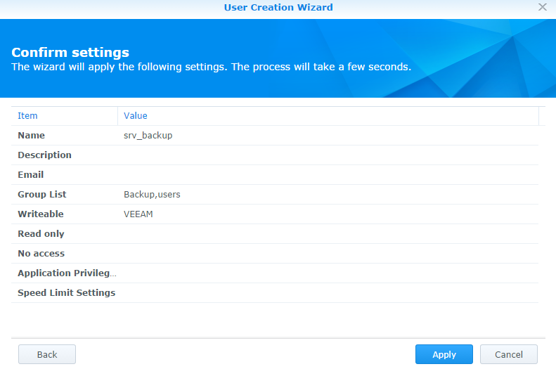

## Create group to prevent web login

Control Panel >> Group >> Create

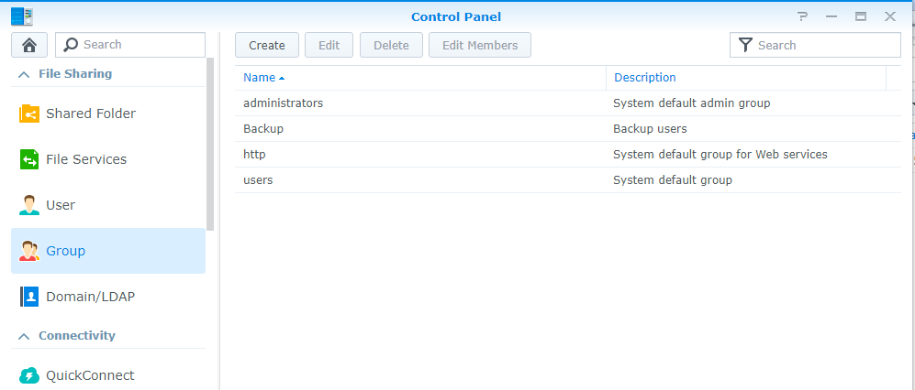

Create NoWebAcces user

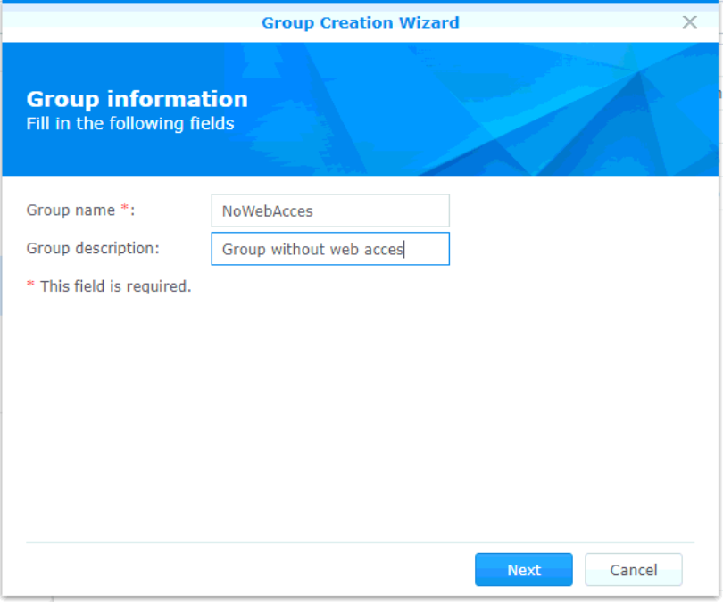

No Folder Permissions

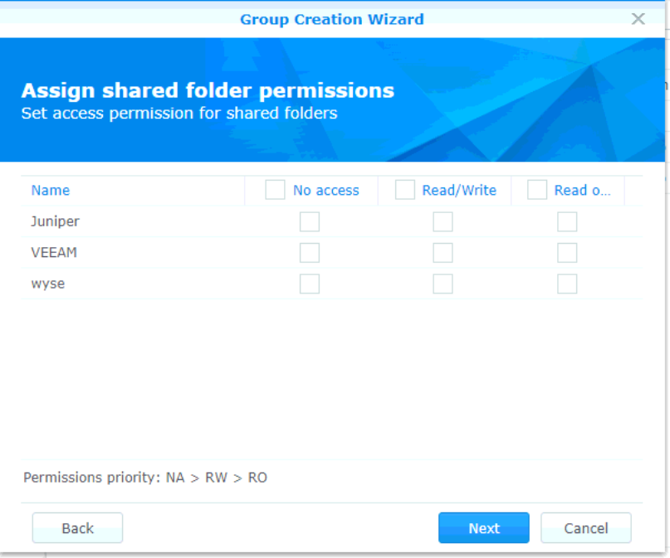

No Quota settings

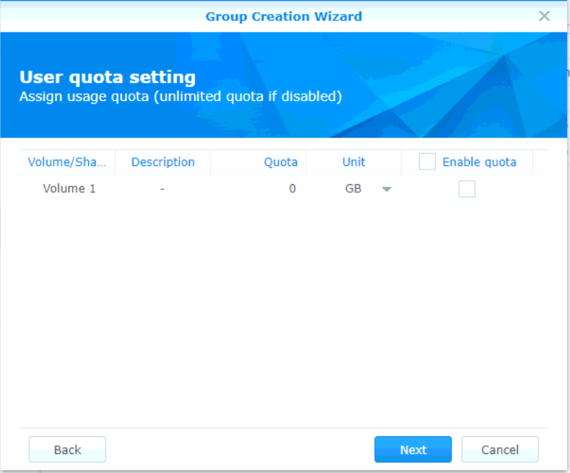

Deny All applications, NOT FTP

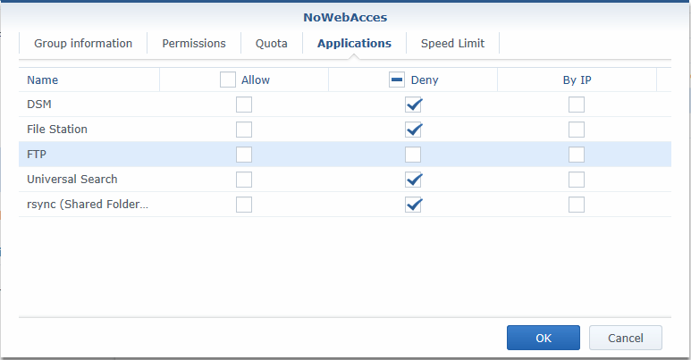

Add users using edit members

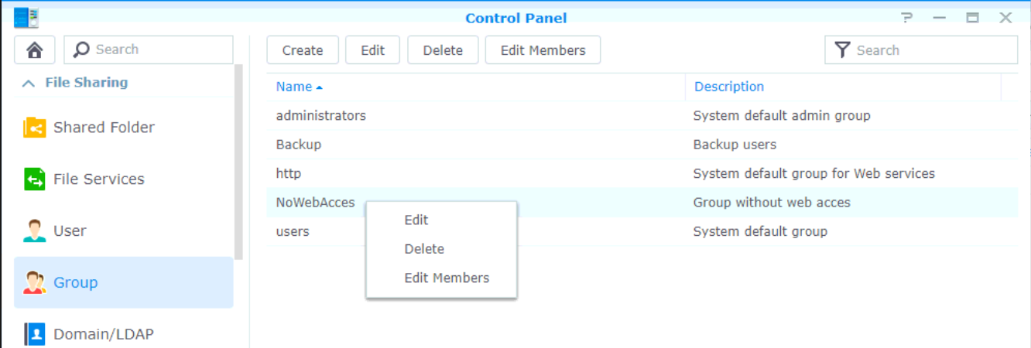

Add

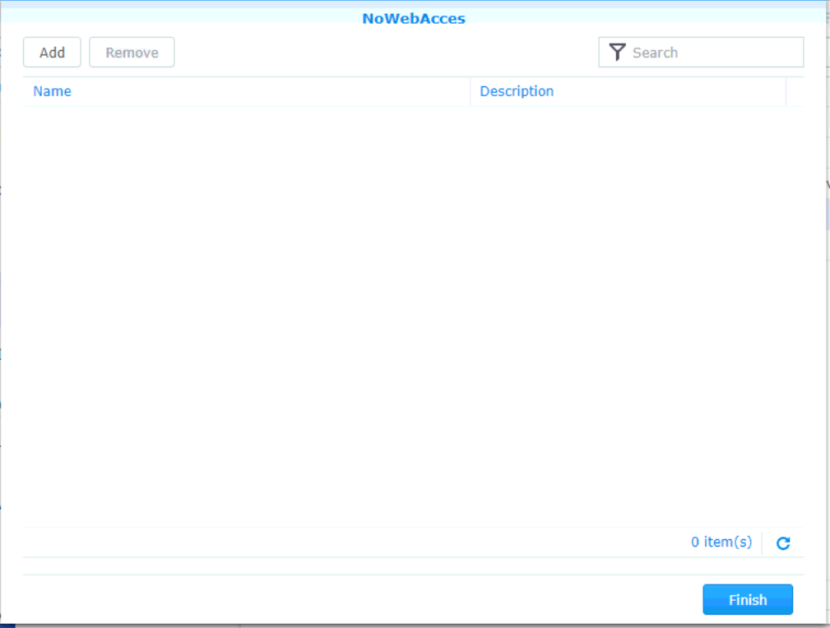

Select All exept Admin.

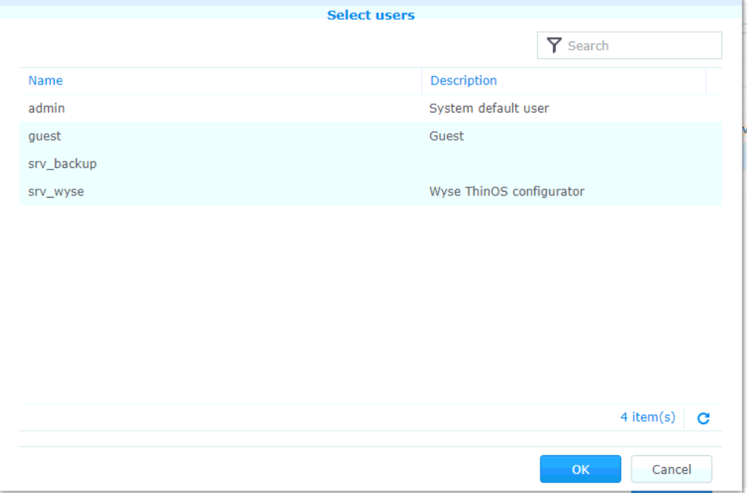

Finish.

## Set up monitoring (SNMP)

Control Panel >> Terminal & SNMP >> SNMP

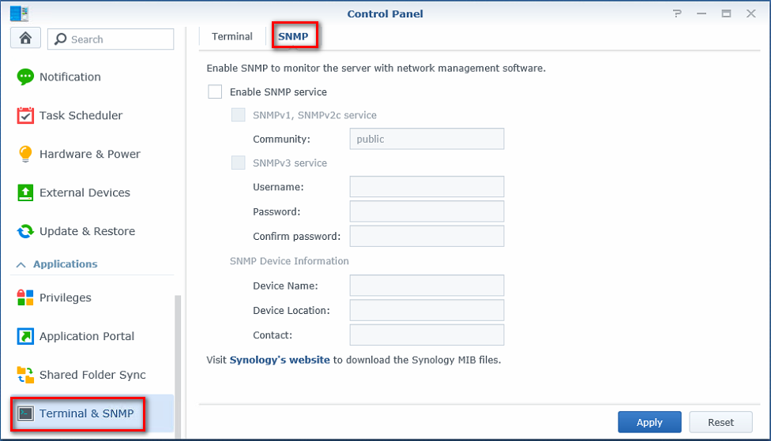

Community: SNMP-RO

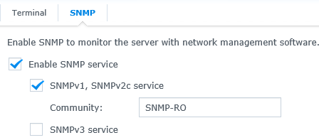

## Enable SSH

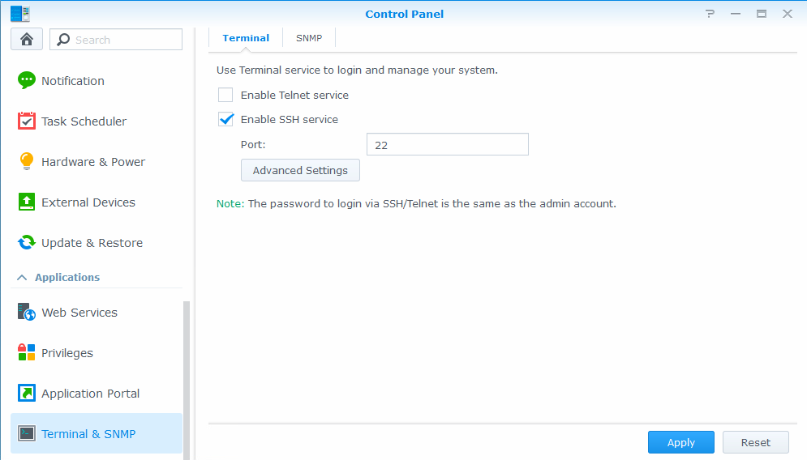

## Enable Monthy Raid Scrub

Open [Storage Manager]

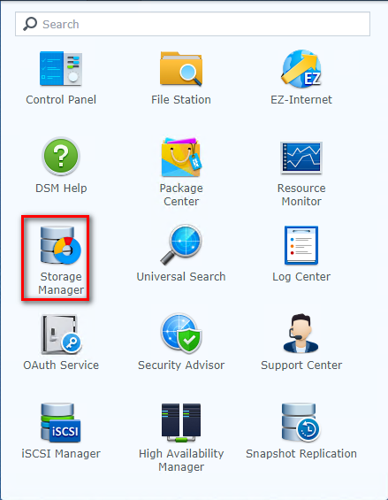

Go to [Storage Pool] >> [Data Scrubbing] >> [Set Schedule]

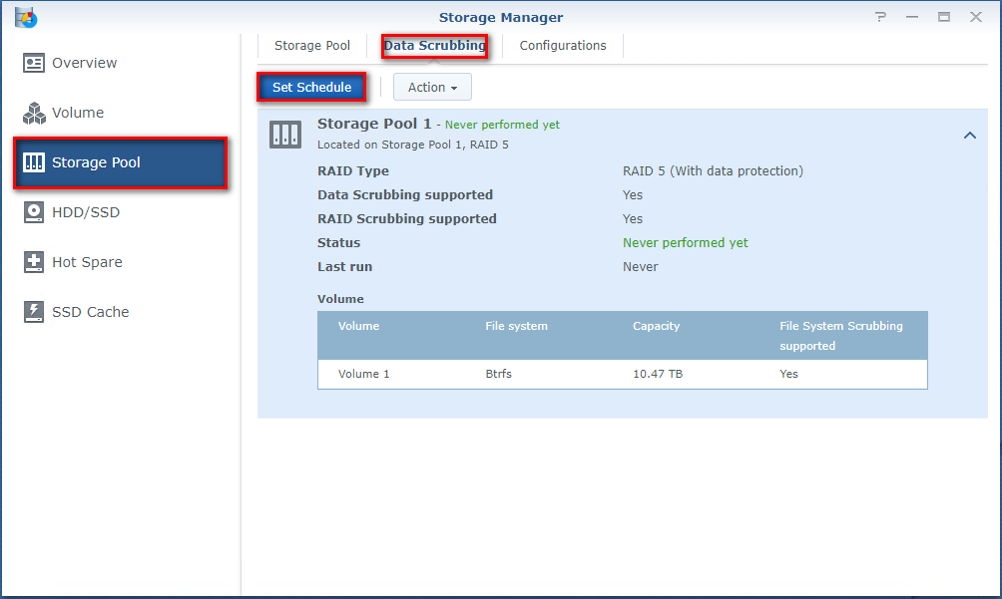

Enable [Data Scrubbing Schedule]

Set [Repeat montly] and set it to the 29th of the month

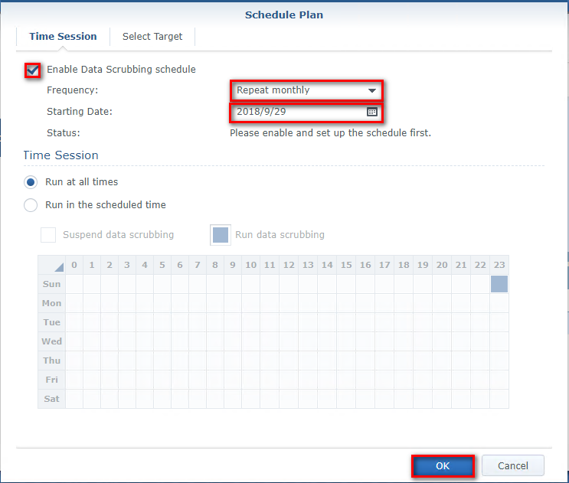

Select [Storage Pool 1]

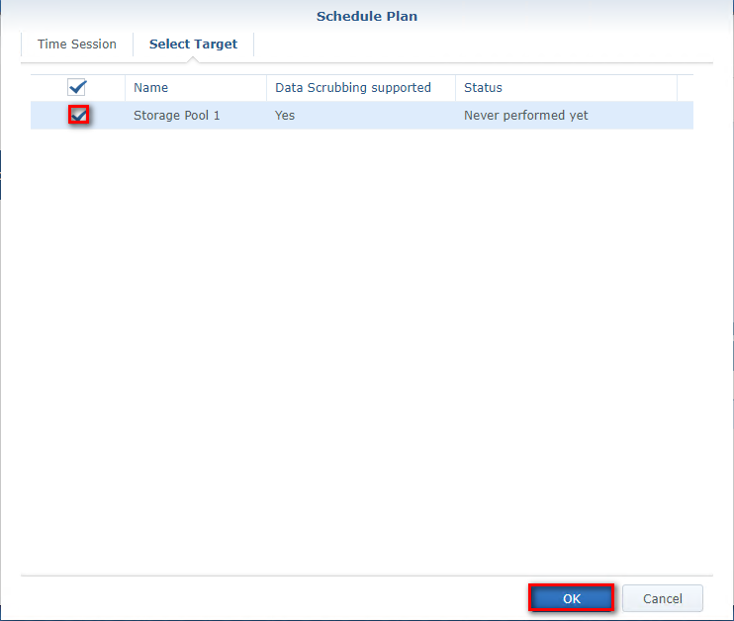

## Disable AFP Service

Control Panel >> File Services >> SMB/AFP/NFS

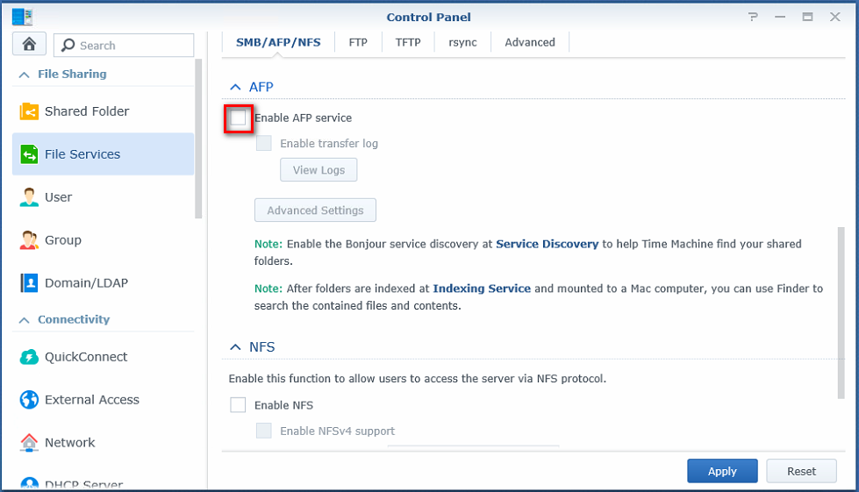

## Enable Notifications

Control Panel >> Notification >> Email

For a ship, fill in as the example below

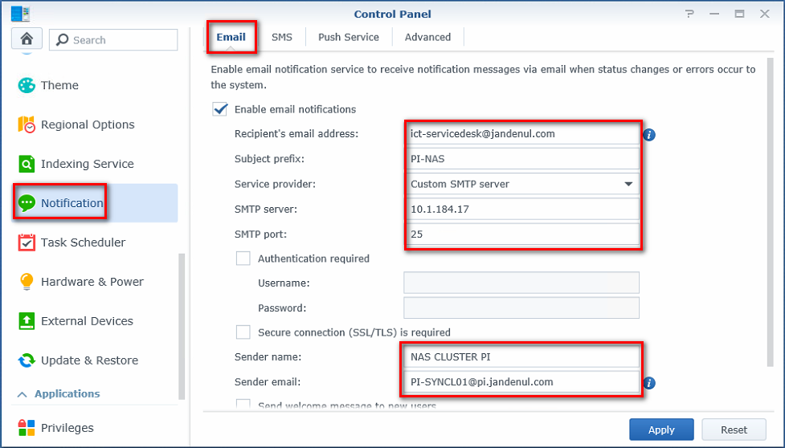

For offices, fill in as the example below

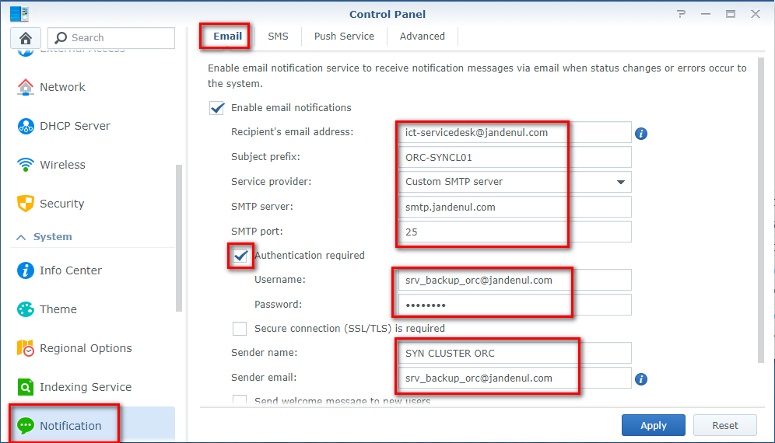

## Adjust Notifications

Open and Close Advanced.

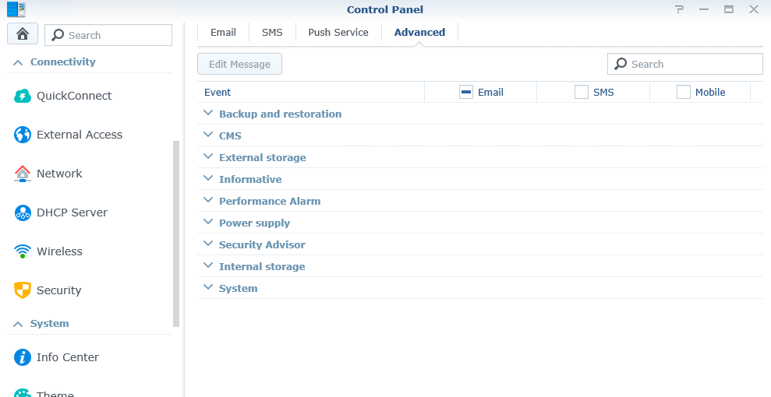

Copy script folder SetNotifications from below location/TFS to the MGMT.

\\Jdn-file01\ict_new_standard_sites_vessels\Scripted Install\Synology (1.1)

Run the script; enter the Admin password and Synology IP.

The script will now enable and disable the required Notification messages.

## Adjust Notifications

Storage Manager >> HDD/SSD >> General

Deselect [Send monthly disk health report via mail]

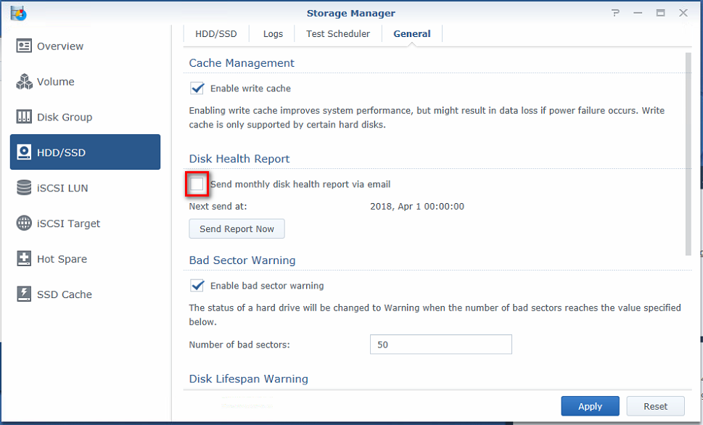

Errors will be send anyway the moment they occur.

## Login Style

Control Panel > Theme > Login Style

**Login page Title:** <vesselname> Backup NAS

**Welcom Title:** UNAUTHORIZED USE OF THIS SYSTEM IS STRICTLY PROHIBITED!

**Welcome Message:** Please contact the ICT-Servicedesk to gain access.

